To work through this example set, you first need to ensure you have installed the following applications onto your machine.

1. Python (v2.7 or v3.4)
2. DROID v6.1.5

You might also want to install a dev environment. Sublime Text is very good and well used.

Next you will need to grab the test set of file. They are available from here:

<http://digitalcorpora.org/corp/files/govdocs1/threads/thread0.zip>

Download the zip file to an appropriate location on your machine, and unpack the zip file into its own folder. You should see something like this:-

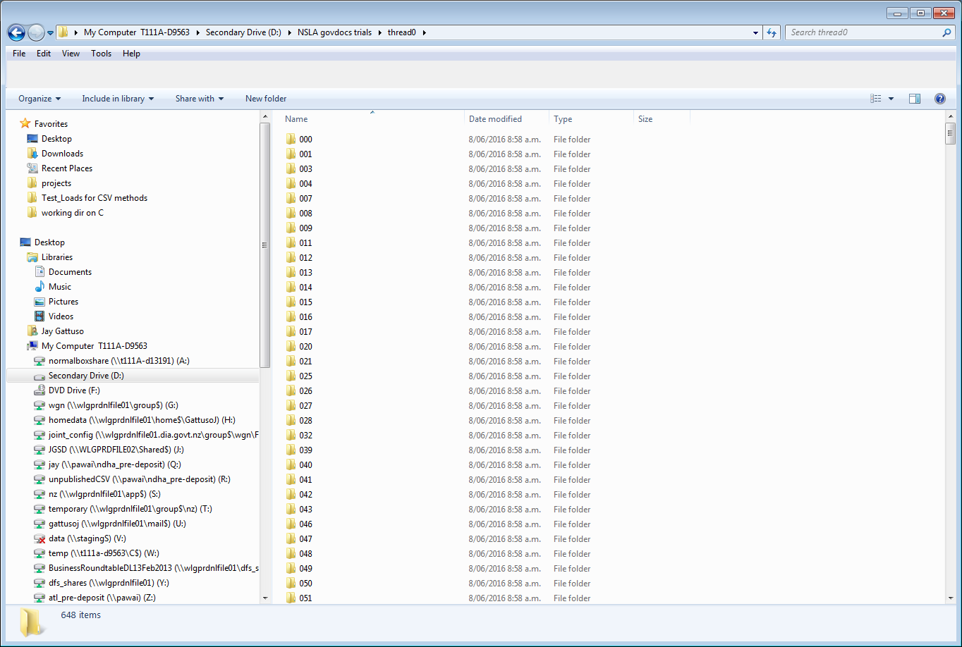

Next you need to set your DROID to behave in the same way as the baseline. Open the preferences menu in “tools”:-

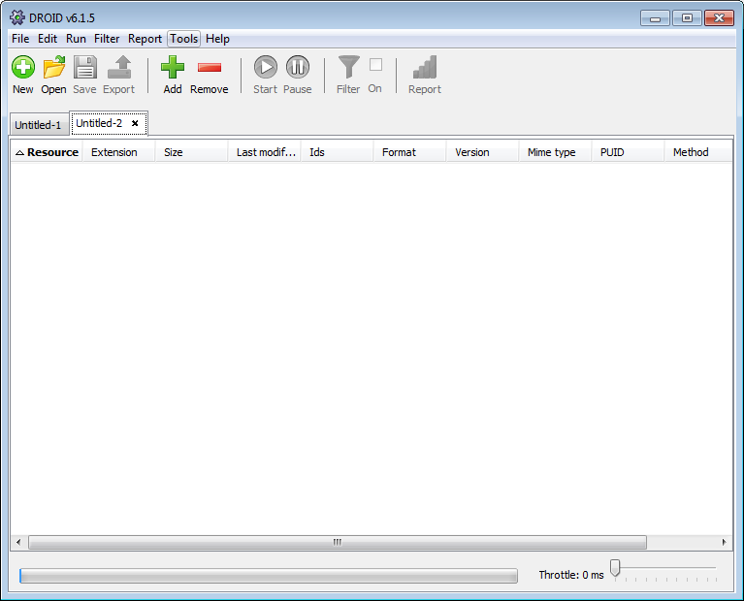

And make sure your DROID settings are:-

* MSB = 65536
* Binary Sig: v84
* Container Sig: v20151218
* Match extensions if no other sigs defined
* Make MD5 hash per file

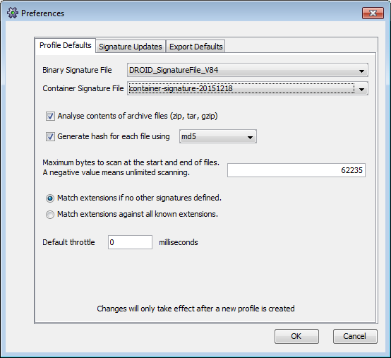

If you need to get copies of signature files you can find them on the PRONOM website:

<http://www.nationalarchives.gov.uk/aboutapps/pronom/droid-signature-files.htm>

When you are happy they are the same, click OK.

If you have had to change anything in the preferences, create a new profile:-

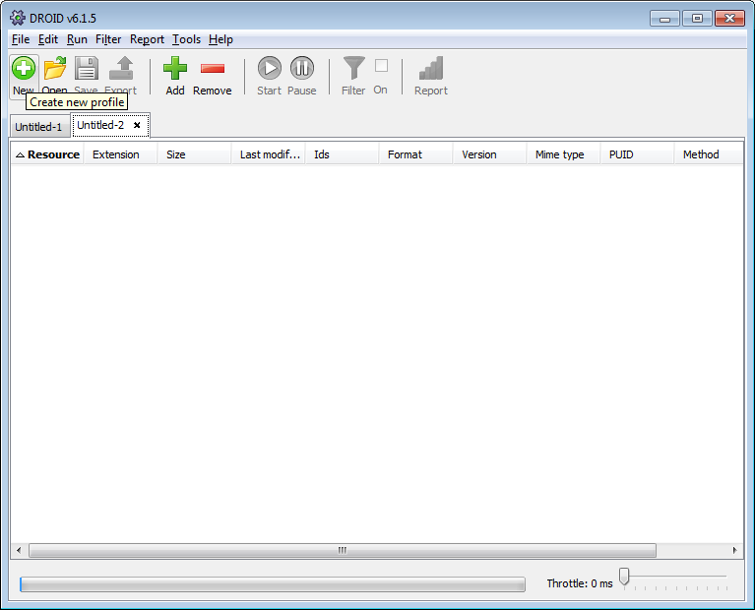

Add files to the DROID profile:-

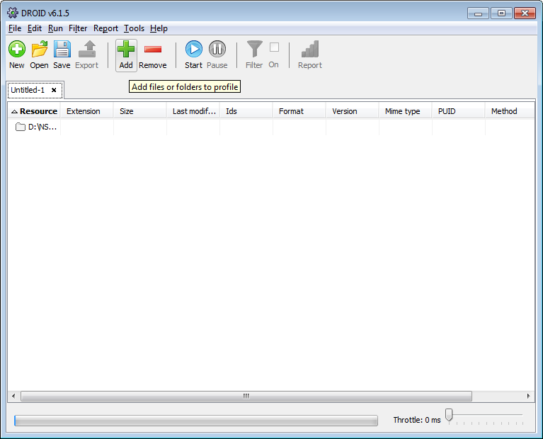

Point to unpacked folder at the top level:-

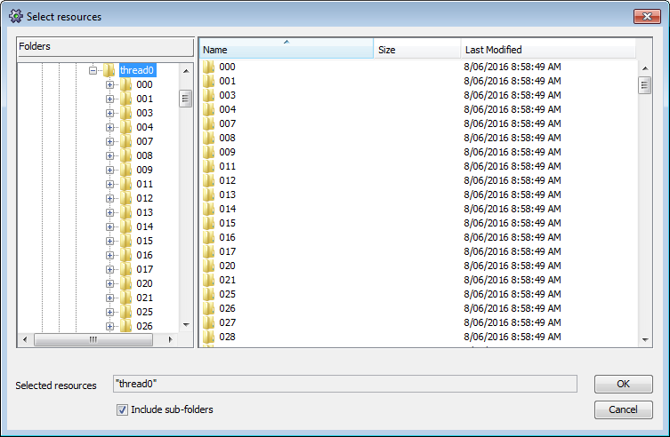

Run DROID:-

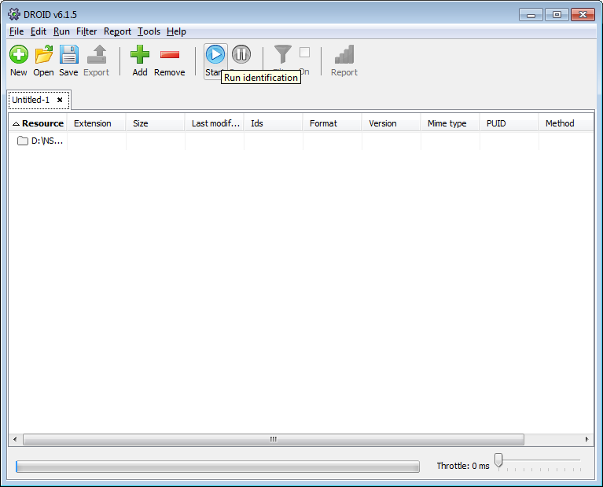

When complete, export results:-

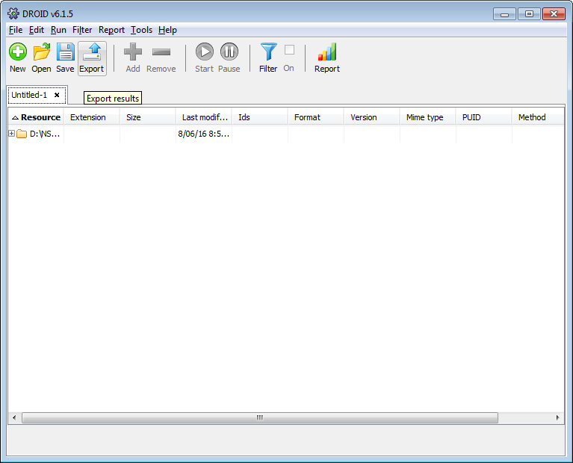

Pick your “profile”, set to one row per file. Click Export profiles:-

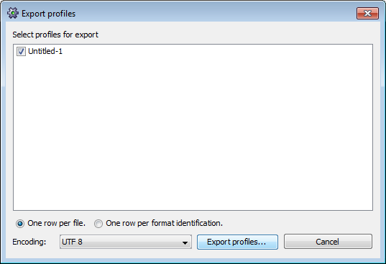

If you needed to start a create a new profile, make sure you select the correct profile here.

Label your log file accordingly and save.

Once you have saved the log file you will need to clean it of information that will complicate the comparison step. You can do this by running the “DROID_export_cleaner.py”. This script will:

* Remove the “Folder” type rows – these are not needed for this test.
* Remove the first few data elements of each row – these will be specific to your files and will make the comparison difficult.
* Sort the results into alphanumerical order – this will allow us to do a row-by-row comparison
* Save a new version of the cleaned results – this will be used to compare against the baseline.csv

Run the python script “DROID_export_cleaner.py” either from command line (python “DROID_export_cleaner.py” or in your environment

The next step is to compare your results with the baseline results.

Make sure the filenames in “DROID_export_comparer.py” match your files, and run the comparison between the two cleaned log files.

Take a note of any information that is posted to the terminal – this will tell you how the comparison task went.

If you get no errors or problems, you should see something like this in your terminal window:-

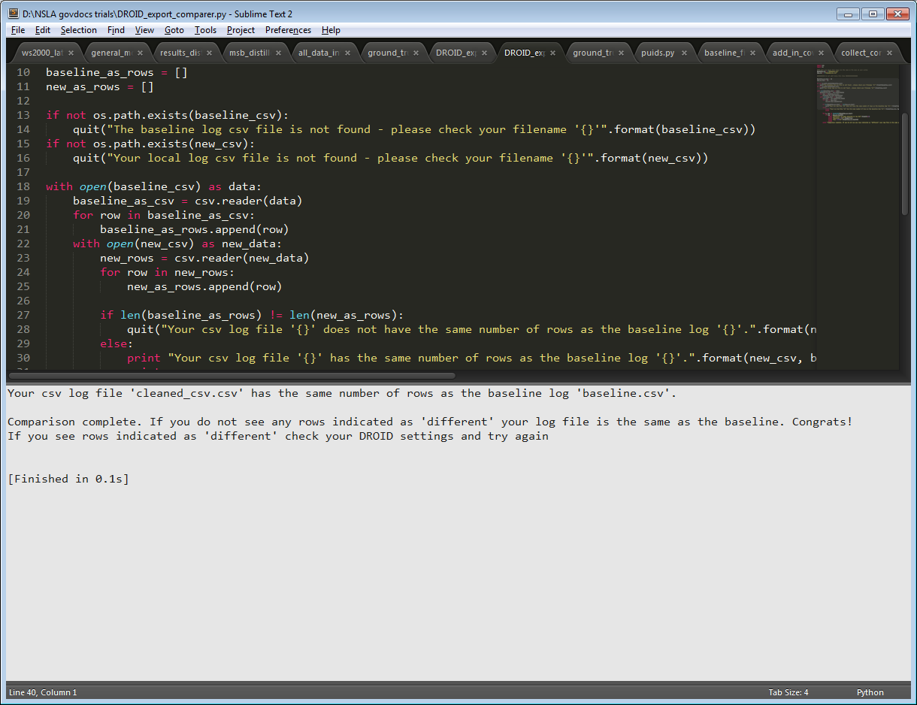

If you do have some differences in your rows, you should see a message like this:-

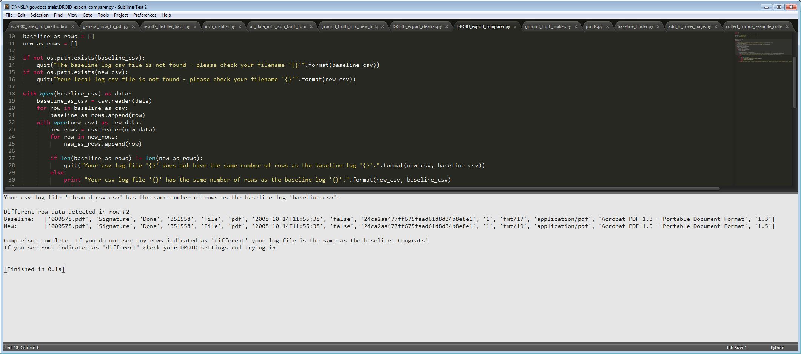

This script should also inform you if it can’t find the required csv files.